Subtotal
 1 бр
Used
White Wedge, Plate 3 x 4 without Stud Notches
EUR 0.044
(~BGN 0.0861)
In Stock: 18
EUR 0.04
Remove
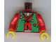1 бр
Used
Red Torso Castle Ninja Vest Green Tattered Pattern (Robber) / Red Arms / Yellow Hands
EUR 0.445
(~BGN 0.8703)
In Stock: 1
EUR 0.45
Remove
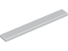3 бр
New
Light Bluish Gray Tile 1 x 8
EUR 0.236
(~BGN 0.4616)
In Stock: 324
EUR 0.71
Remove
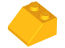1 бр
Used
Bright Light Orange Slope 45 2 x 2
EUR 0.035
(~BGN 0.0685)
In Stock: 8
EUR 0.04
Remove
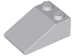1 бр
Used
Light Bluish Gray Slope 33 3 x 2
EUR 0.08
(~BGN 0.1565)
In Stock: 2
EUR 0.08
Remove
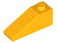 1 бр
Used
Bright Light Orange Slope 33 3 x 1
EUR 0.079
(~BGN 0.1545)
In Stock: 3
EUR 0.08
Remove
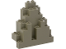2 бр
Used
Dark Gray Rock Panel 3 x 8 x 7 Triangular (LURP)
EUR 1.402
(~BGN 2.7421)
In Stock: 5
EUR 2.80
Remove
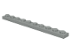1 бр
Used
Light Gray Plate 1 x 10
EUR 0.159
(~BGN 0.311)
In Stock: 70
EUR 0.16
Remove
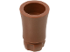5 бр
Used
Brown Plant, Tree Palm Trunk - Long Indented Connector
EUR 1.016
(~BGN 1.9871)
In Stock: 10
EUR 5.08
Remove
1 бр
Used
Green Plant, Tree Palm Leaf Small 8 x 3
EUR 0.289
(~BGN 0.5652)
In Stock: 1
EUR 0.29
Remove
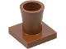1 бр

Used
Brown Plant, Tree Palm Base
EUR 0.981
(~BGN 1.9187)
In Stock: 4
EUR 0.98
Remove
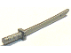4 бр
Used
Flat Silver Minifigure, Weapon Sword, Shamshir/Katana (Square Guard) with Capped Pommel and Holes in Crossguard and Blade
EUR 0.07
(~BGN 0.1369)
In Stock: 93
EUR 0.28
Remove
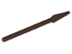1 бр
Used
Dark Brown Minifigure, Weapon Pike / Spear - Round End
EUR 0.315
(~BGN 0.6161)
In Stock: 1
EUR 0.32
Remove
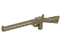1 бр
Used
Dark Gray Minifigure, Weapon Gun, Rifle
EUR 0.443
(~BGN 0.8664)
In Stock: 11
EUR 0.44
Remove
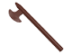1 бр
Used
Brown Minifigure, Weapon Axe, Halberd
EUR 1.734
(~BGN 3.3914)
In Stock: 8
EUR 1.73
Remove
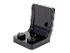1 бр
New
Black Minifigure, Utensil Seat (Chair) 2 x 2 with Center Sprue Mark
EUR 0.132
(~BGN 0.2582)
In Stock: 23
EUR 0.13
Remove
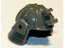1 бр
Used
Dark Gray Minifigure, Headgear Helmet Ninja (Samurai)
EUR 0.568
(~BGN 1.1109)
In Stock: 2
EUR 0.57
Remove
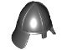1 бр
Used
Black Minifigure, Headgear Helmet Castle with Neck Protector
EUR 1.025
(~BGN 2.0047)
In Stock: 6
EUR 1.03
Remove
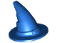1 бр
Used
Blue Minifigure, Headgear Hat, Wizard / Witch
EUR 0.477
(~BGN 0.9329)
In Stock: 8
EUR 0.48
Remove
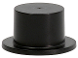 2 бр
Used
Black Minifigure, Headgear Hat, Top Hat
EUR 0.253
(~BGN 0.4948)
In Stock: 26
EUR 0.51
Remove
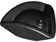 1 бр
Used
Black Minifigure, Headgear Hat, Pirate Tricorne / Triangle
EUR 0.753
(~BGN 1.4727)
In Stock: 20
EUR 0.75
Remove
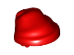1 бр
Used
Red Minifigure, Headgear Hat, Cloth Wrap / Bandana
EUR 0.289
(~BGN 0.5652)
In Stock: 51
EUR 0.29
Remove
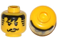 1 бр
Used
Yellow Minifigure, Head Moustache Black Bangs, Striped Sideburns Pattern - Hollow Stud
EUR 0.308
(~BGN 0.6024)
In Stock: 1
EUR 0.31
Remove
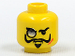1 бр
Used
Yellow Minifigure, Head Glasses with Monocle, Scar, and Goatee Pattern - Blocked Open Stud
EUR 0.227
(~BGN 0.444)
In Stock: 1
EUR 0.23
Remove
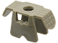1 бр
Used
Dark Gray Minifigure Armor Ninja Style
EUR 0.638
(~BGN 1.2478)
In Stock: 1
EUR 0.64
Remove
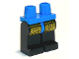1 бр
Used
Blue Hips and Black Legs with Castle Ninja Leg Armor Pattern
EUR 0.406
(~BGN 0.7941)
In Stock: 3
EUR 0.41
Remove
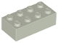2 бр
Used
Light Gray Brick 2 x 4
EUR 0.203
(~BGN 0.397)
In Stock: 2
EUR 0.41
Remove
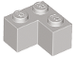 2 бр
Used
Light Gray Brick 2 x 2 Corner
EUR 0.141
(~BGN 0.2758)
In Stock: 14
EUR 0.28
Remove
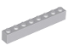1 бр
New
Light Bluish Gray Brick 1 x 8
EUR 0.384
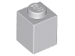4 бр
New
Light Bluish Gray Brick 1 x 1
EUR 0.097
(~BGN 0.751)
In Stock: 11
EUR 0.38
Remove

Subtotal (46 items): EUR 20.27 (~BGN 39.64)

