Shopping Cart - 120 items / 34 lots
Image
Condition
Description
Each
Quantity
Subtotal
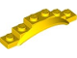
Used
Yellow Vehicle, Mudguard 1 1/2 x 6 x 1 with Arch
EUR 0.061
(~BGN 0.1193)
In Stock: 12
EUR 0.24
Remove
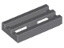
New
Dark Bluish Gray Tile, Modified 1 x 2 Grille with Bottom Groove / Lip
EUR 0.042
(~BGN 0.0821)
In Stock: 439
EUR 0.50
Remove
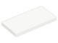
New
White Tile 2 x 4
EUR 0.303
(~BGN 0.5926)
In Stock: 5
EUR 0.30
Remove
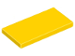
New
Yellow Tile 2 x 4
EUR 0.214
(~BGN 0.4185)
In Stock: 51
EUR 0.43
Remove
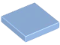
Used
Medium Blue Tile 2 x 2 with Groove
EUR 0.073
(~BGN 0.1428)
In Stock: 2
EUR 0.15
Remove

Used
Yellow Tile 2 x 2 with Groove
EUR 0.049
(~BGN 0.0958)
In Stock: 9
EUR 0.05
Remove
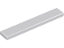
New
Light Bluish Gray Tile 1 x 6
EUR 0.202
(~BGN 0.3951)
In Stock: 13
EUR 1.21
Remove

Used
Yellow Tile 1 x 4
EUR 0.058
(~BGN 0.1134)
In Stock: 9
EUR 0.12
Remove
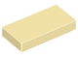
New
Tan Tile 1 x 2 with Groove
EUR 0.101
(~BGN 0.1975)
In Stock: 44
EUR 0.20
Remove
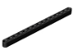
New
Black Technic, Liftarm Thick 1 x 15
EUR 0.452
(~BGN 0.884)
In Stock: 18
EUR 0.90
Remove
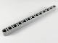
New
Light Bluish Gray Technic, Liftarm Thick 1 x 13
EUR 0.561
(~BGN 1.0972)
In Stock: 3
EUR 1.68
Remove
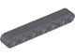
Used
Dark Bluish Gray Technic, Liftarm Thick 1 x 7
EUR 0.065
(~BGN 0.1271)
In Stock: 8
EUR 0.13
Remove
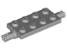
Used
Light Bluish Gray Plate, Modified 2 x 4 with Pins
EUR 0.025
(~BGN 0.0489)
In Stock: 22
EUR 0.05
Remove
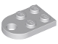
New
Light Bluish Gray Plate, Modified 2 x 3 with Hole
EUR 0.059
(~BGN 0.1154)
In Stock: 3
EUR 0.18
Remove
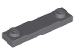
New
Dark Bluish Gray Plate, Modified 1 x 4 with 2 Studs without Groove
EUR 0.042
(~BGN 0.0821)
In Stock: 61
EUR 0.34
Remove
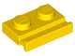
Used
Yellow Plate, Modified 1 x 2 with Door Rail
EUR 0.049
(~BGN 0.0958)
In Stock: 6
EUR 0.20
Remove
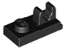
Used
Black Plate, Modified 1 x 2 with Clip on Top
EUR 0.025
(~BGN 0.0489)
In Stock: 216
EUR 0.10
Remove
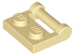
Used
Tan Plate, Modified 1 x 2 with Bar Handle on Side with Closed Ends
EUR 0.042
(~BGN 0.0821)
In Stock: 44
EUR 0.25
Remove
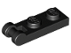
New
Black Plate, Modified 1 x 2 with Bar Handle on End - Closed Ends
EUR 0.033
(~BGN 0.0645)
In Stock: 179
EUR 0.10
Remove
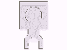
Used
White Plate, Modified 1 x 1 with U Clip Thin (Vertical Grip)
EUR 0.066
(~BGN 0.1291)
In Stock: 24
EUR 0.07
Remove
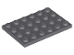
New
Dark Bluish Gray Plate 4 x 6
EUR 0.14
(~BGN 0.2738)
In Stock: 14
EUR 0.14
Remove
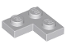
New
Light Bluish Gray Plate 2 x 2 Corner
EUR 0.099
(~BGN 0.1936)
In Stock: 56
EUR 0.20
Remove
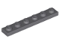
New
Dark Bluish Gray Plate 1 x 6
EUR 0.092
(~BGN 0.1799)
In Stock: 230
EUR 0.92
Remove
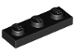
New
Black Plate 1 x 3
EUR 0.101
(~BGN 0.1975)
In Stock: 33
EUR 0.81
Remove
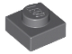
New
Dark Bluish Gray Plate 1 x 1
EUR 0.075
(~BGN 0.1467)
In Stock: 15
EUR 0.30
Remove
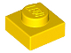
Used
Yellow Plate 1 x 1
EUR 0.041
(~BGN 0.0802)
In Stock: 154
EUR 0.29
Remove
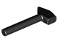
Used
Black Minifigure, Utensil Tool Mallet / Hammer
EUR 0.049
(~BGN 0.0958)
In Stock: 82
EUR 0.10
Remove
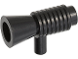
Used
Black Minifigure, Utensil Loudhailer / Megaphone / SW Blaster
EUR 0.041
(~BGN 0.0802)
In Stock: 216
EUR 0.04
Remove
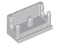
New
Light Bluish Gray Hinge Brick 1 x 2 Base
EUR 0.149
(~BGN 0.2914)
In Stock: 12
EUR 0.45
Remove
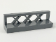
New
Dark Bluish Gray Fence 1 x 4 x 1
EUR 0.30
(~BGN 0.5867)
In Stock: 7
EUR 0.90
Remove
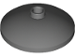
Used
Dark Bluish Gray Dish 3 x 3 Inverted (Radar)
EUR 0.066
(~BGN 0.1291)
In Stock: 52
EUR 0.26
Remove
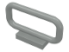
Used
Light Gray Bar 1 x 4 x 2
EUR 0.148
(~BGN 0.2895)
In Stock: 3
EUR 0.30
Remove

Used
Red Arch 1 x 6 x 3 1/3 Curved Top
EUR 0.915
(~BGN 1.7896)
In Stock: 4
EUR 1.83
Remove
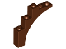
Used
Reddish Brown Arch 1 x 5 x 4 - Continuous Bow
EUR 0.139
(~BGN 0.2719)
In Stock: 1
EUR 0.14
Remove

Subtotal (120 items): EUR 13.87 (~BGN 27.13)

